Abdulla Al-malki (202009135)

Ahmed Deef (201606478)

Mohammed Al-Obaidly(201801987)

Youssef Ahmed (202107162)

Emails:

[aa2009135@qu.eu.qa](mailto:aa2009135@qu.eu.qa)

[ya2107162@qu.edu.qa](mailto:ya2107162@qu.edu.qa)

[ad1606478@qu.edu.qa](mailto:ad1606478@qu.edu.qa)

[ma1801987@qu.edu.qa](mailto:ma1801987@qu.edu.qa)

fetch cache options

|  |  |  |
| --- | --- | --- |
| Page | Caching strategy | Reasoning |
| Login | No-store | User data could change and we need to check that whenever we login |
| Home | No-store | New conference dates could be added in the future and papers |
| Staff/ | No-store, force-cache | More papers could be published later or sessions or reviews  But some data like locations can be stored in the cache with no issue |

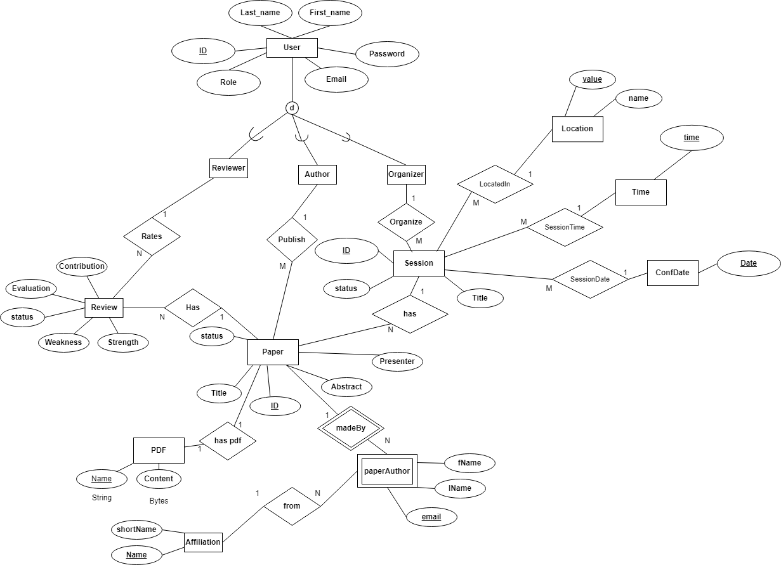

Technical Lessons Learned:

1. The first ERD does not need to be absolutely correct the first time. The advantage of prisma migrations is that we can always update our schema whenever we find we missed something or need to modify. At the same time, the rest of the team could work on the project using prisma client with little modifications needed later. The key here is saving time working on the project while the schema gets modified.
2. Cache options need to be taken care of. Some sensitive data could be needed to stay up to date and force-cache options will not make them work in the right way.
3. Initially starting UI with react saves time as layouts give the ability to reuse components shared by many pages.

Improvement actions:

Contribution:

Abdulla 30%:

Frontend, actions, react, assisting.

Mohammed 25%:

Server-side, route, repo.

Youssef 25%:

Server-side, actions, seed, schema assistance.

Ahmed 20%:

ER diagram, schema model, seed assistance